Samiksha Prashant Pawar

Roll No.16

|  |
| --- |
| class Product: def __init__(self, name, price, stock): self.name = name self.price = price self.stock = stock  def update_stock(self, quantity): self.stock += quantity  print("Stock updated successfully!")  def __str__(self): return f"Product: {self.name}, Price: ₹{self.price}, Stock:  {self.stock}"  def main(): products = {}  while True: print("\n1. Add a new product")  print("2. Update stock of an existing product") print("3. View product details") print("4. Exit")    choice = input("Enter your choice: ")  if choice == '1': name = input("Enter product name: ") price = float(input("Enter product price: ")) stock = int(input("Enter product stock: ")) products[name] = Product(name, price, stock) print("Product added successfully!")  elif choice == '2': name = input("Enter product name to update: ") if name in products: quantity = int(input("Enter quantity to add/remove:  "))  products[name].update_stock(quantity) else: print("Product not found!")  elif choice == '3': name = input("Enter product name: ") if name in products: |

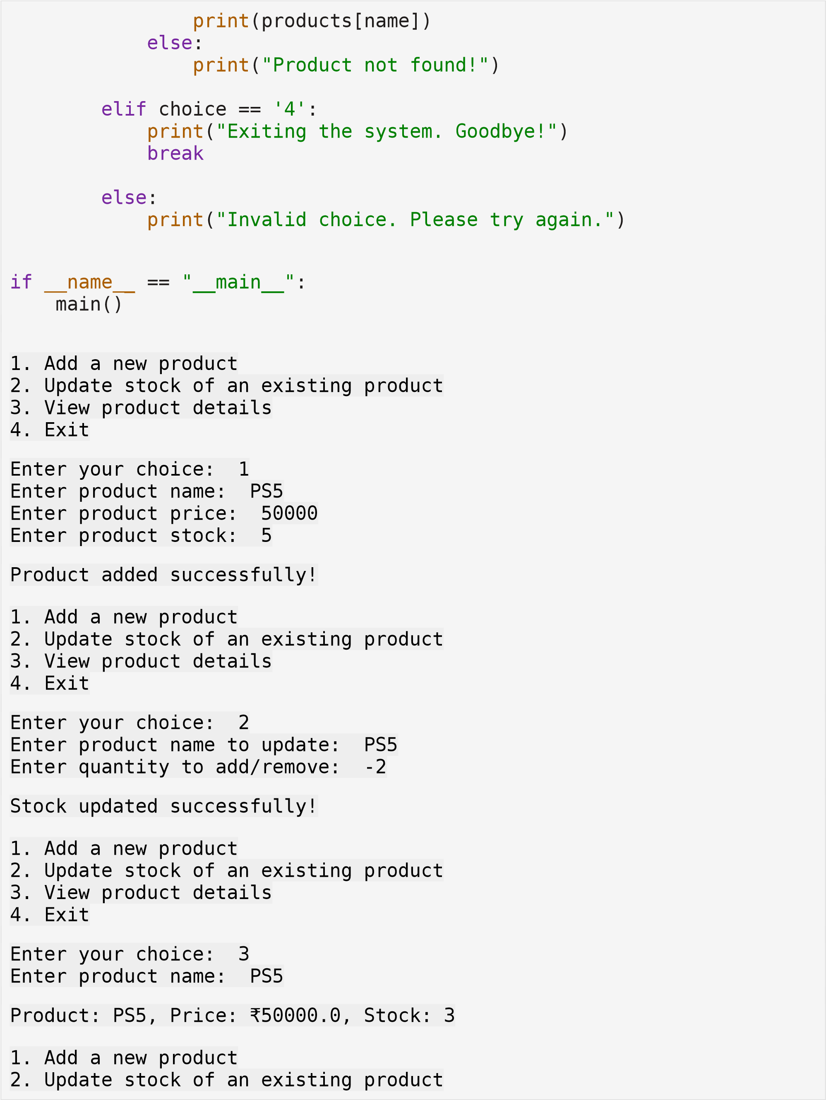

|  |  |  |  |  |  |  |  |  |  |  |  |  |
| --- | --- | --- | --- | --- | --- | --- | --- | --- | --- | --- | --- | --- |
| |  |  |  | | --- | --- | --- | | 3. View product details | | | | 4. Exit |  | | | Enter your choice: 4 | | | Exiting the system. Goodbye! | | | | |